**KAJJANSI HIGH SCHOOL**

**SET 2 ASSESSMENTS TERM ONE 2024**

**GEOGRAPHY S.3**

**TIME: 2 HOURS**

**INSTRUCTIONS**

* Attempt **ALL** questions

1Geography is related with Chemistry in a way that when studying chemical composition and changes which take place in soils and rocks, chemistry knowledge is applied.

**Support material**

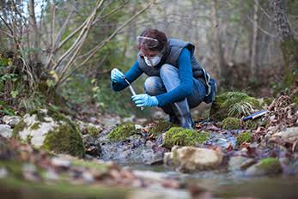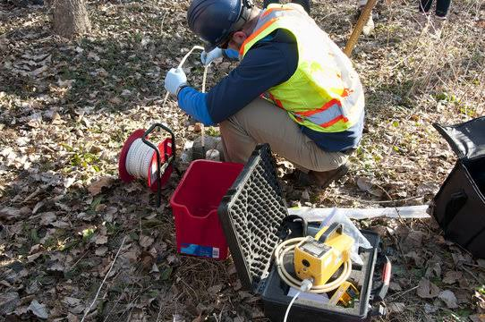

**Tasks**

a) So as a learner who studied introduction to Geography, how is Geography related to physics? (01 mark)

………………………………………………………………………………………………………………………………………………………………………………………………………………

b) One of the layers of the atmosphere from the earth’s surface upwards is Troposphere. What are other two layers? (02 marks)

………………………………………………………………………………………………………………………………………………………………………………………………………………

c) **Read the article below and answer the questions that follow.**

Pollution is said to be the biggest killer in developing countries. This contaminates air, water and soil which claim millions of lives every year. And with rapid urbanization and economic growth has raised fears that these numbers will continuous keep increasing in years to come. In our country Uganda, the effects of pollution on people are becoming visible.

Air pollution has become one of the biggest challenges faced in Uganda especially in urban centers. In Uganda the main cause of air pollution is transport especially rapid motorization that is being experienced in urban areas. According to Dr. William Worodria air pollution has multiple effects and particularly the lungs, the heart and other body systems

**Support material**

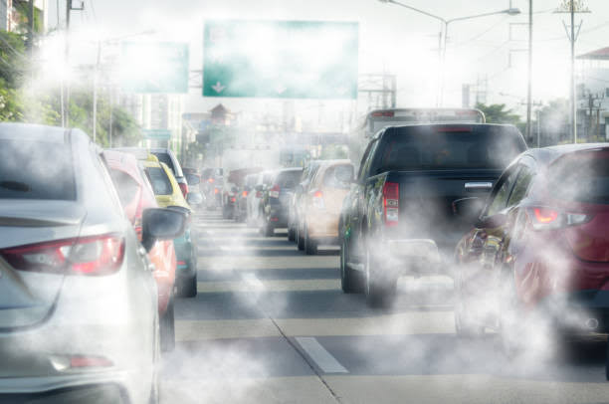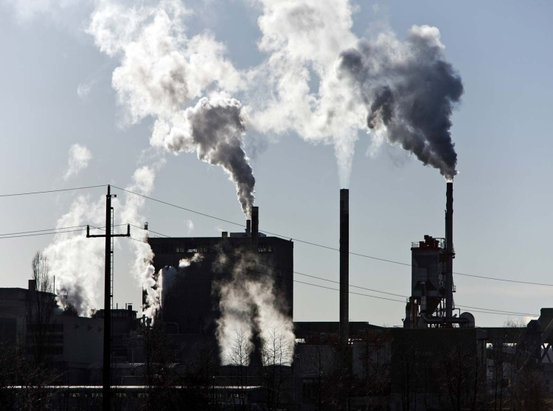

**Tasks**

a). In your opinion what do you understand by the term “pollution”. (01 mark)

………………………………………………………………………………………………………………………………………………………………………………………………………………

b) As mentioned from the article above, transport is the biggest cause of air pollution in Uganda. State and explain any other **three** causes of pollution in Uganda. (06 marks)

………………………………………………………………………………………………………………………………………………………………………………………………………………………………………………………………………………………………………………………………………………………………………………………………………………………………………………………………………………………………………………………………………………………………………………………………………………………………………………

c) Assuming you are an environmentalist, what **five** measures could you put in place to conserve and preserve environment for the future generation. (05 marks)

………………………………………………………………………………………………………………………………………………………………………………………………………………………………………………………………………………………………………………………………………………………………………………………………………………………………………………………………………………………………………………………………………………………………………………………………………………………………………………………………………………………………………………………………………………………………………………………………………………………………………………………………………………………………………………………………………………………………………………………………………………………………………………………………………………

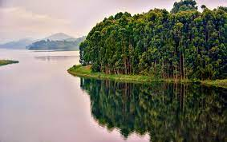2. Study the figure below and answer the questions that follow below

Having studied different ways of learning and studying geography,

a). Draw a sketch of the photograph above in a frame of 15cm by 10cm in the space provided and in it mark and name;

i) A hill in the left back ground of the photograph.

ii) Vegetation in the right middle and right back grounds of the photograph.

iii) Water body in the left fore, left middle and left back ground of the photograph. (06 marks)

**Space to draw a photograph sketch**

b). The vegetation around the water body is very important for modification of climate through formation of rain fall. Give any other **four** uses of the vegetation around the water body.

(05 marks)

………………………………………………………………………………………………………………………………………………………………………………………………………………………………………………………………………………………………………………………………………………………………………………………………………………………………………………………………………………………………………………………………………………………………………………………………………………………………………………………………………………………………………………………………………………………

c). Assume you stay around the place in photograph; state any two human activities with reasons you would engage in apart from fishing. (04 marks)

………………………………………………………………………………………………………………………………………………………………………………………………………………………………………………………………………………………………………………………………………………………………………………………………………………………………

**END**